Nomenclature of common Functional groups
Beside the nomenclature of alkanes, the functional groups covered so far are halo alkanes (which are equal lowest priority, along with alkanes), alkynes, and alkenes.
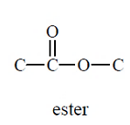
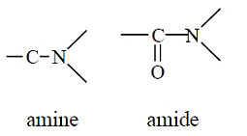
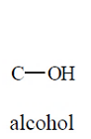
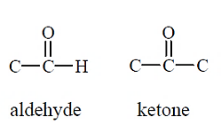
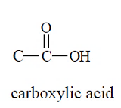
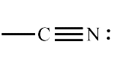
Other common classes of functional groups contain the atoms oxygen or/and nitrogen. Brief diagrams of the functional groups in this course are shown below.
nitrile
The nomenclature of these functional groups in this course is based on the IUPAC system, which has certain nomenclature rules and assigns a priority to each functional group. See the table below for that priority order of the functional groups. The highest priority functional group ina molecule is named as part of the main chain, using a suffix at the end of the main chain name. Functional groups with a lower priority are named as substituent group, using a prefix and listed alphbetically before the main name. Each functional group therefore has two ways of being named – as a suffix, and as a prefix. This “how to” guide will go through the naming of each of these functional groups.
This guide will explain nomenclature in the same order of priority that the functional groups have, starting with the lowest priority of the functional groups – see the list below. As halo alkanes (alkyl halides), alkynes, and alkenes have already been covered, these notes start with amines and move up through the priority listing.
When you are naming a molecule with more than one functional group, you first meed to identify which has highest priority – and design your name accordingly.
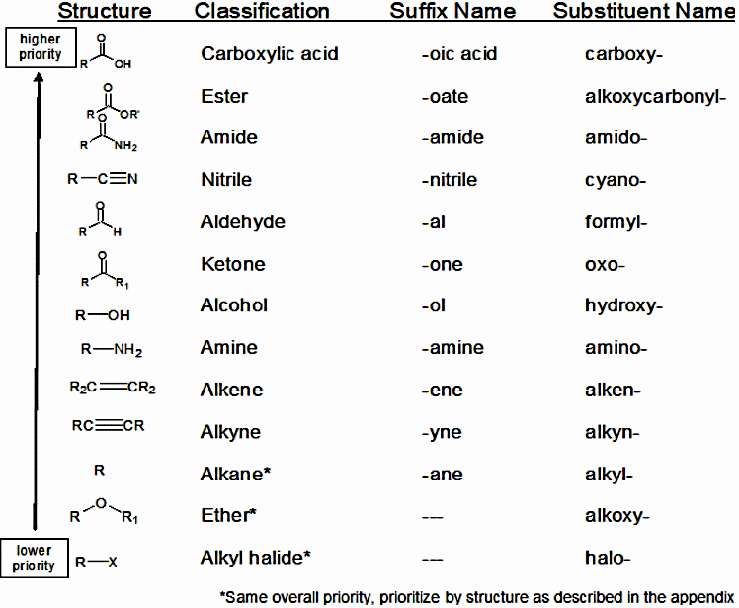
The priority order is NOT the order that these functional groups are covered in your text book. I do not think this is a big issue, and I make that note just to explain why I have discussed nomenclature of the functional groups in the order I have. Note that ethers are in the list on the right. Ethers are not part of this course and are therefore not discussed below.

Amines
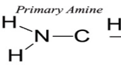
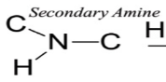
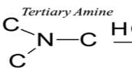
An Amine contains carbon atoms which are single bonded to a N atom. Since Nitrogen can form three single bonds, there are three different types of amines - primary amines (one C-N bond to NH₂), secondary amines (two C-N bonds to NH), and tertiary amines (three C-N bonds to N).

Nomenclature rules for Primary amines:
1) Amine groups have priority over any double, triple bonds, alkyl groups, and halogen groups, but not other functional groups. If the amine present has the highest priority, select as the main chain, the longest carbon chain that contains the carbon attached to the nitrogen. Name this main chain according to the number of carbons (meth, eth, etc) and replace 'ane' with 'amine' (eg propanamine).
2) Number the chain from the end such that the carbon attached to the amine group has the lowest number. Prefix the name with this number (eg. 1-propanamine or propan-1-amine, where the NH₂ group is attached to the first carbon).
2-propanamine
NH₂

NH₂

2-butanamine
3) Where there is more than one amine group use the point of first difference rule for the amine positions. List each number in front of the main name and the appropriate prefix (di-, tri-, etc.). An example would be 1,2-propandiamine or propan-1,2-diamine.
4) Where the amine group is NOT the highest priority group, it is named like any other substituent group using the prefix amino. A number, as in 4-amino…, indicates the position of the amine group.
Nomenclature rules for secondary and tertiary amines
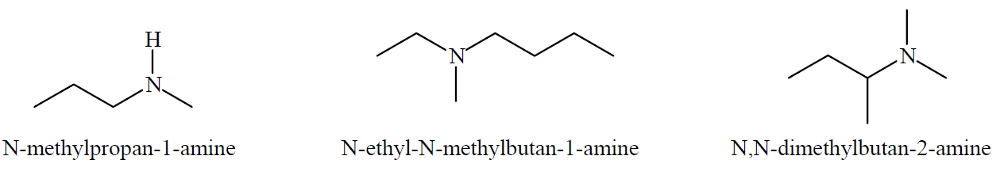
1) Assuming the amine is the highest priority group, each carbon chain which comes from the Nitrogen is named. The longest of these is named as if it was a primary amine using the rules above. The other carbon chains bonded to the N are named as alkyl substituents with the prefix N, and are listed alphabetically in front of the main chain name.
NOTE – Secondary and tertiary amines, especially symmetrical ones, are commonly named without the N reference or the numbers.
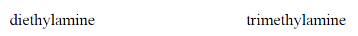
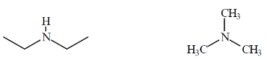

Alcohols
An alcohol contains the hydroxyl group (-OH) bonded to a carbon atom anywhere in the molecule.
Nomenclature rules:
  - Alcohol groups have priority over any amine, double, triple bonds, alkyl groups, and halogen groups, but not other functional groups. If the OH group present has the highest priority, select as the main chain the longest continuous carbon chain that contains the carbon attached to the alcohol group. Name this main chain according to the number of carbons (meth, eth etc) and replace 'ane' with 'anol' (eg butanol).
  - Number the chain from the end such that the carbon which the -OH is attached to, has with the lowest number. Prefix the name with this number (eg. 2–butanol, where the OH group is attached to the second carbon).
  - Name other less priority groups with the rules learnt earlier, but with the same numbering system you used for the OH group as it has priority.
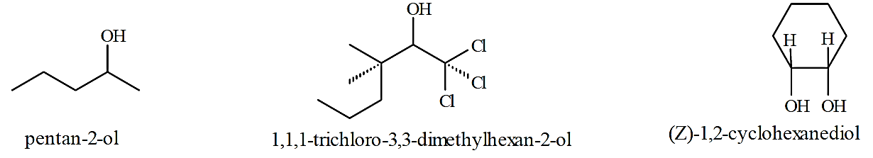
  - If the alcohol is not the highest priority group it is named as a substituent, using the prefix hydroxy, and a number to indicate its position.

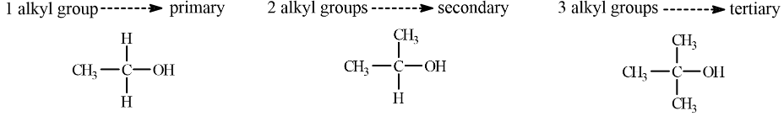
No necessary for nomenclature, but you will need to know this information later - Compounds such as alcohols may also be classified as being primary (1°), secondary (2°) or tertiary (3°). Note this is a very different type of classifying than the amines, even though the same words (primary, secondary, and tertiary) are used. In the case of alcohols the classification depends on the number of alkyl groups bonded to the carbon attached to the -OH group, not the number of alkyl groups attached to the OH group itself.

Ketones
A ketone contains a carbonyl group (C=O) attached at a non-terminal carbon. This means that the carbon double bonded to the oxygen must be single bonded to two other carbons. Thus the smallest ketone would be a 3 carbon unit – propanone.
Nomenclature rules:
- Ketone functional groups have priority over any alcohol, amine, double, triple bonds, alkyl groups, and halogen groups, but not other functional groups. If the ketone group present has the highest priority, select as the main chain, the longest continuous carbon chain that contains the carbon attached to the carbonyl group. Name this main chain according to the number of carbons (meth, eth etc.) and replace 'e' with 'one' (e.g. butanone).
- Number the chain such that the carbonyl carbon has the lowest number. Prefix the name with this number.
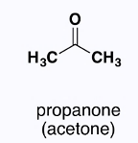
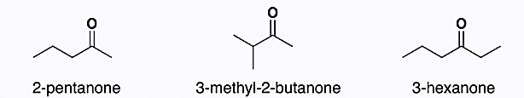
- Name other functional groups as substituents, with a number and a prefix – see table on first page.

Aldehydes
An aldehyde contains a carbonyl group (C=O) at the end of a carbon chain (ie. a terminal carbon). There is only H also bonded to this terminal carbon.
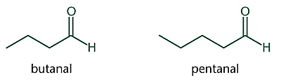
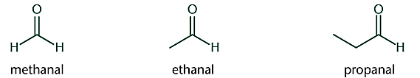
Nomenclature rules:
  - Aldehyde functional groups have priority over any ketone, alcohol, amine, double, triple bonds, alkyl groups, and halogen groups, but not other functional groups. If the aldehyde group present has the highest priority, select as the main chain, the longest continuous carbon chain that contains the carbon attached to the carbonyl group. Name this main chain according to the number of carbons (meth, eth etc.) and replace 'e' with 'al' (e.g. butanal). You do not have to use a number for this functional group when it has the highest priority as it is assumed to be at the 1 carbon.
  - If other functional groups of lower priority are present, number the main chain starting with the aldehyde carbon as number one.
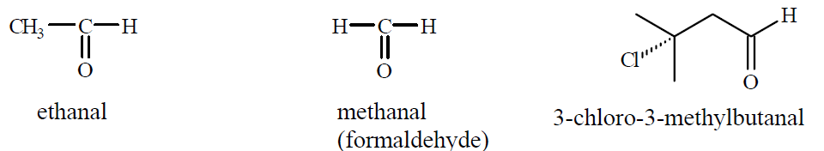
  - Name other functional groups with a number and a prefix – see table on first page.
Nitriles
Nitriles contain the CN functional group. This is a carbon atom triple bonded to a nitrogen. Because of the triple bond the carbon forms only one other single bond and so it must be a terminal carbon – at one end of the molecule.
Nomenclature rules:
- Nitrile functional groups have priority over any aldehyde, ketone, alcohol, amine, double, triple bonds, alkyl groups, and halogen groups, but not other functional groups. If the nitrile group present has the highest priority, select as the main chain, the longest continuous carbon chain that contains the carbon attached to the Nitrogen. Name this main chain according to the number of carbons (meth, eth etc.) and add nitrile to the end of the name (no space). You do not have to use a number for this functional group when it has the highest priority as it is assumed to be at the 1 carbon.
- If other functional groups of lower priority are present, number the main chain starting with the nitrile carbon as number one.
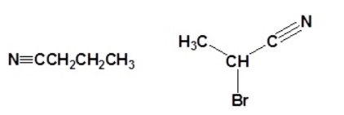
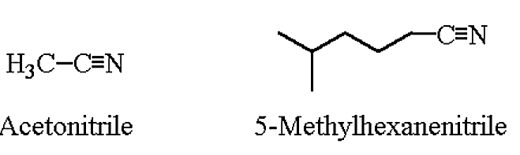
- Name the lower priority functional groups as substituents, with a number and a prefix – see table on first page.
Butanenitrile 2-Bromopropanenitrile Ethanenitrile 5-Methylhexanenitrile

Amides
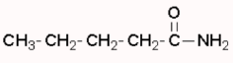
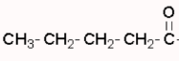
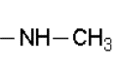
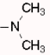
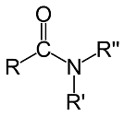
Amides contain the CON functional group. This is a carbon with a carbonyl group and a single bond to a nitrogen atom. The number of carbons attached to the Nitrogen atom determine if it is a primary (no carbons), Secondary (one carbon), or tertiary (two carbons) amide.
General formula Primary Amide Secondary amide Tertiary amide
Nomenclature rules:
- Amide functional groups have priority over any nitrile, aldehyde, ketone, alcohol, amine, double, triple bonds, alkyl groups, and halogen groups, but not other functional groups. If the amide group present has the highest priority, select as the main chain, the longest continuous carbon chain that contains the carbon attached to the carbonyl group and the Nitrogen. Name this main chain according to the number of carbons (meth, eth etc.) and replace the “e” with “amide” at the end of the name. You do not have to use a number for this functional group when it has the highest priority, as it is assumed to be at the 1 carbon.
- The carbon chains in secondary and tertiary and tertiary amides are named as if they were substituent groups (that is methyl, ethyl etc.), but with a prefix of N- (like nitriles).
- If other functional groups of lower priority are present, number the main chain, starting with the carbon which has both carbonyl and N attached as number one.
- Name the lower priority functional groups with a number and a prefix – see table on first page.
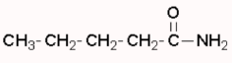
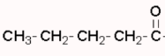
N,N-dimethylpentanamide
pentanamide
N-methylpentanamide

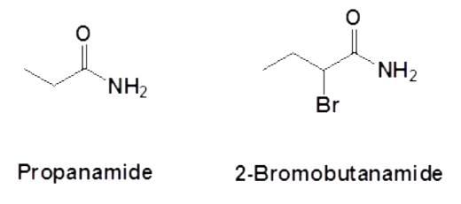
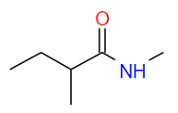
N,2-dimethylbutanamide

Esters
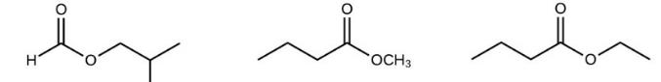
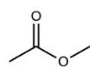
Esters contain the COO functional group. This is a carbon with a carbonyl group (=O)and a single bond to another oxygen atom (-O-), which in turn, is single bonded to another carbon chain. The ester functional group therefore joins two carbon chains together.
General structure
R
R¹

Nomenclature rules:
- Ester functional groups have priority over any other functional group except carboxylic acids. If the ester group present is the highest priority, select as the main chain, the longest continuous carbon chain that contains the carbon attached to both the carbonyl group and the second oxygen. Name this main chain according to the number of carbons (meth, eth etc.) and replace the “e” with “oate” at the end of the name. You do not have to use a number for this functional group when it has the highest priority, as it is assumed to be at the 1 carbon.
- The second carbon chain, which is single bonded to oxygen in the ester group is named like a substituent (methyl, ethyl etc.), BUT is not joined to the main chain name in any way (see examples below) like normal substituent nomenclature.
- If other functional groups of lower priority are present, number the main chain, starting with the carbon which has both carbonyl and O attached as number one.
- Name the lower priority functional groups with a number and a prefix – see table on first page. These names become part of the main chain name, after the name of the second carbon chain of the ester (see last example below).
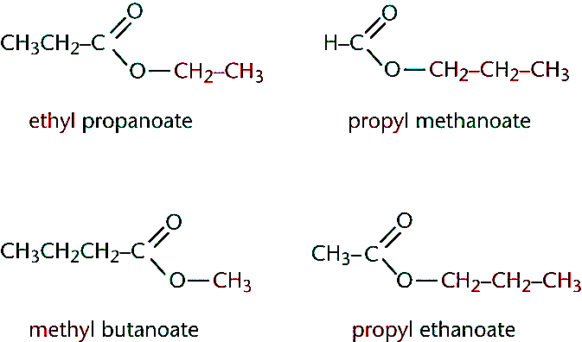
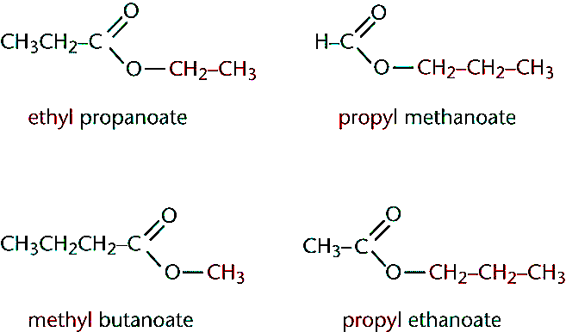
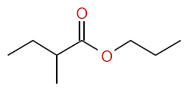
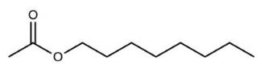
octyl methanoate
propyl 2-methylbutanoate

Carboxylic (Organic) acids
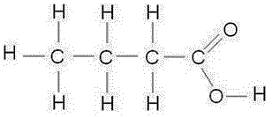
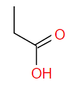
Carboxylic acids contain the COOH functional group. This is made of a carbonyl group and an alcohol group (OH) bonded to a terminal carbon. Because of the polarity within the structure the OH group is chemically v different to an alcohol. The additional polarity caused by the nearby carbonyl group causes the OH group to act as a weak acid, and release a portion of H⁺ ions in solution.
General structure
R
H

Nomenclature rules:
- Carboxylic acid functional groups have priority over any other functional group. If present, a carboxylic acid is the highest priority and therefore select the main chain as the longest continuous carbon chain that contains the carbon in the carboxylic acid group. Name this main chain according to the number of carbons (meth, eth etc.) and replace the “e” with “oic acid” at the end of the name. You do not have to use a number for this functional group as it has the highest priority and is assumed to be at the 1 carbon.
- If other functional groups of lower priority are present, number the main chain, starting with the carbon within the carboxylic acid group as number one.
- Name the lower priority functional groups as substituents, with a number and a prefix – see table on first page. These names become part of the main chain name.
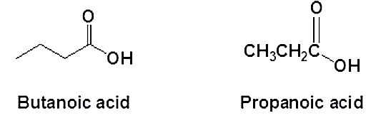
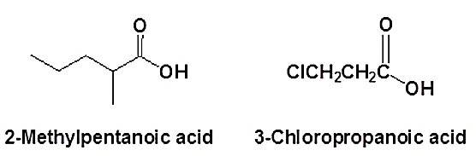
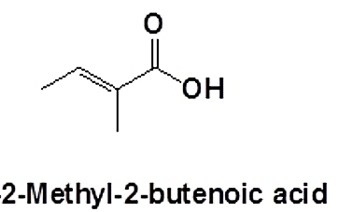

Stereoisomerism
Stereoisomers are molecules which have the same structural formulas, but different arrangements of their atoms in space. Another way of saying this is that the atoms are connected together in the same sequence, but are positioned differently in space.
Enantiomers – is a form of stereoisomerism. Enantiomers are often referred to as optical isomers as they are molecules which form mirror images of each other.
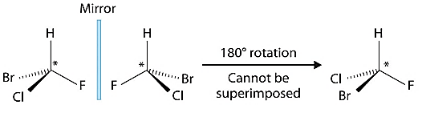
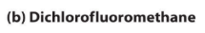
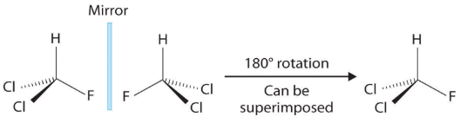
The difference between enantiomers can only be seen when the three-dimensional arrangement of the molecules is examined. Consider the two molecules below – the first has two enantiomers with the same structural formula and name. The second does not exhibit this type of stereoisomerism. Identifying or naming enantiomers is difficult (look for a plane of symmetry) and is not part of this course.

Geometric isomerism.
Geometric isomerism is another type of stereoisomerism. This type of isomerism shows up in some alkenes and is caused by the lack of free rotation about a double bond.
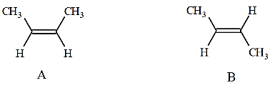
Consider the two compounds on the right – both are 2- butane and share the same name and structure, but are not superimposable upon each other – they are geometric isomers.
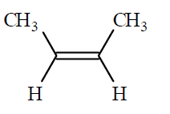
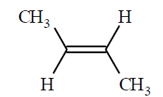
Geometric isomers can be named in two ways, depending on whether they are simple structures or more complex. A simple geometric isomer is like the example of A and B above – there a carbon group and hydrogen on either end of the double bond. Simple geometric isomers are named using a cis/trans nomenclature. Cis is where the two carbon groups are on the same side of the double bond (example A), and trans is when the two carbon groups are on opposite sides of the double bond.
cis-2-butene
trans-2-butene

More complex geometric isomers are named using an E and Z notation. This is not part of our course, but is well explained at https://www.chemguide.co.uk/basicorg/isomerism/ez.html

